EXPERIMENT NO.1

AIM: - WRITE THE BASIC HTML.5 DOCUMENT STRUCTURE AND IMPLIMENT ALL SIX HEADING TAGS (<H1>TO<H6>) WITH SIMPLE TEXT.

CODE:
<html>
<head>
<title>2610997052</title>
</head>
<body>
EXPERIMENT NO. 1
<br>
<h1>this is the largest heading</h1>
<br>
<h2>this is the second largest heading</h2>
<br>
<h3>this is the third largest heading</h3>
<br>
<h4>this is the fourth largest heading</h4>
<br>
<h5>this is the fifth largest heading</h5>
<br>
<h6>this is the sixth largest heading</h6>
<br>
</body>
</html>

OUTPUT: -

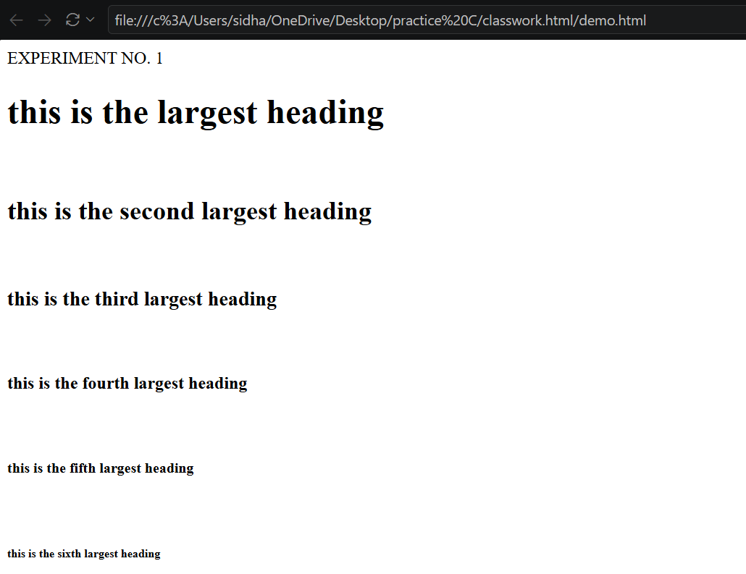

EXPERIMENT NO.2
AIM: - CREATE A PARAGRAPH AND APPLY TEXT FORMATTING TAGS (<b>, <I>, <strong>, <em>) to given content.
CODE: -
<html>
<head>
<title>2610997052</title>
</head>
<body>
EXPERIMENT NO.2
<br>
<p>
<b>HTML is used to create web pages. </b>
<br>
<i>It provides different tags to format and organize the content. </i>
<br>
<strong>HTML is an important language for web development. </strong>
<br>
<em>Learning HTML is the first step towards becoming a web developer. </em>
<br>
</p>
</body>
</html>

OUTPUT: -

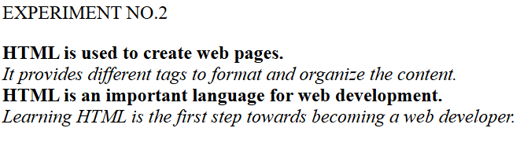

EXPERIMENT NO.3
AIM: - Create an ordered list (<ol>) for a recipe’s steps and unordered list (<ul>) for its ingredients on the same page.
Code: -
<html>
<head>
<title>2610997052</title>
</head>
<body>
EXPERIMENT 3
<h1>Tea Recipe</h1>
<h2>Ingredients</h2>
<ul>
<li>Milk</li>
<li>Water</li>
<li>Tea leaves</li>
<li>Sugar</li>
</ul>
<h2>Steps</h2>
<ol>
<li>Boil water and milk. </li>
<li>Add tea leaves and sugar. </li>
<li>Boil for a few minutes. </li>
<li>Strain the tea and serve hot. </li>
</ol></body>
</html>

OUTPUT: -

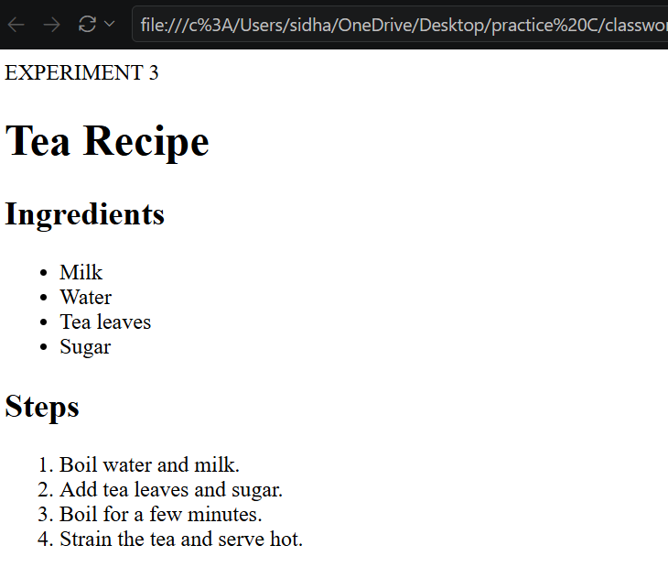

EXPERIMENT NO.4
AIM: - Build a nested list showing a book hierarchy: category- books- chapters using <ul> and <ol> together.

Code:
<html>
<head>
<title>2610997052</title>
</head>
<body>
EXPERIMENT NO.4
<ul>
<li>Science
<ol>
<li>Physics
<ul>
<li>Chapter 1</li>
<li>Chapter 2</li>
</ul>
</li>
<li>Chemistry
<ul>
<li>Chapter 1</li>
<li>Chapter 2</li>
</ul>
</li>
</ol>
</li>
</ul>
</body>
</html>
Output: -

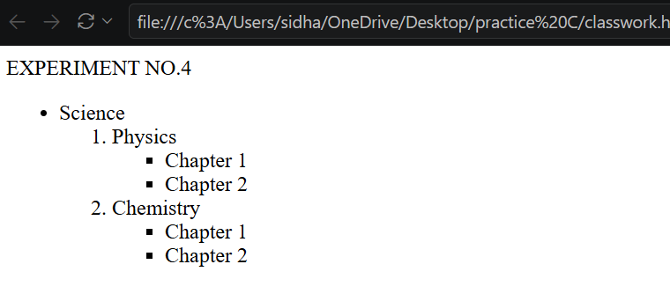

EXPERIMENT NO. 5
AIM: - Inserting an image using <img> and set src, alt, width, height, and title attributes with valid paths.
CODE: -
<html>
<head>
<title>2610997052</title>
</head>
<body>
<h1>Experiment no.5</h1>
<img src="https://i.pinimg.com/736x/db/95/e7/db95e7b9a6e4c30bbda7a6489018cb30.jpg"
alt="tulip"
width="600"
height="500">

</body>
</html>

OUTPUT:-

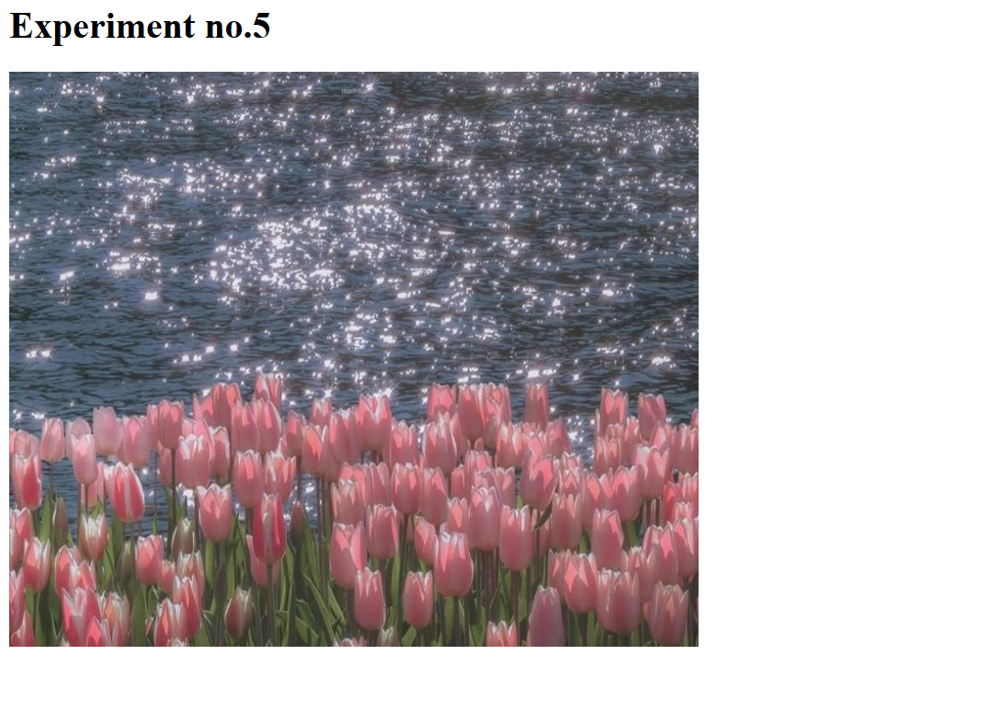

EXPERIMENT NO .6
AIM: - Set a background image for the entire webpage within the <body> tag.
Code: -

<html>
<head>
<title>2610997052</title>
</head>
<body background="https://i.pinimg.com/736x/23/25/16/23251691f292d01245df245c49bd3b04.jpg ">

<h1>Welcome to My Website</h1>
<p>This webpage has a background image. </p>

</body>
</html>

OUTPUT: -



EXPERIMENT NO. 7
AIM: - Create internal anchor links that jump to sections on the same page and one external link to university website.
Code: - <html>
<head>
<title>2610997052</title>
</head>
<body>

<h1>EXPERIMENT NO.7</h1>

<a href= “about">About</a> |
<a href= “courses">Courses</a> |
<a href="https://www.chitkara.edu.in/" target="_blank">University Website</a>

<h2 id="about">About Us</h2>
<p>Welcome to my website. </p>

<h2 id="courses">Courses</h2>
<p> We offer different courses. </p>

</body>
</html>

OUTPUT: -

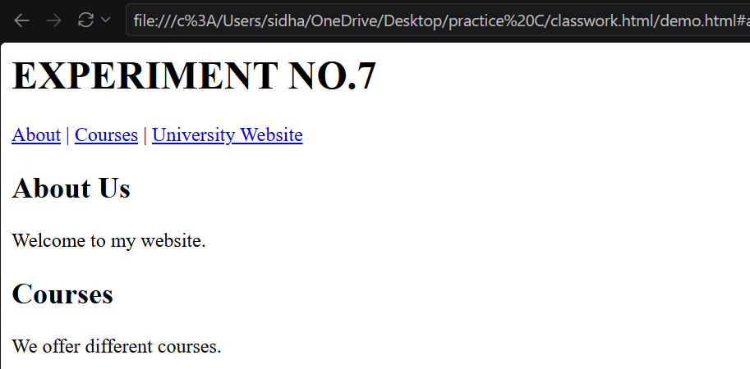



EXPERIMENT NO. 8
AIM: - Create internal anchor links and one external link.
CODE: -
<html>
<head>
<title>26109970</t52itle>
</head>
<body>

<h1>EXPERIMENT NO. 8</h1>

<a href="#about">About</a> |
<a href="#contact">Contact</a> |
<a href="https://www.google.com/">Google</a>

<h2 id="about">About Us</h2>
<p>Welcome to my website. </p>

<h2 id="contact">Contact Us</h2>
<p>Contact us for more information. </p>

</body>
</html>

OUTPUT: -

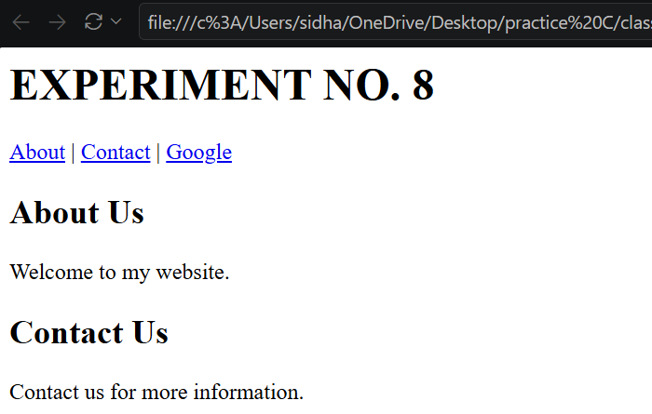

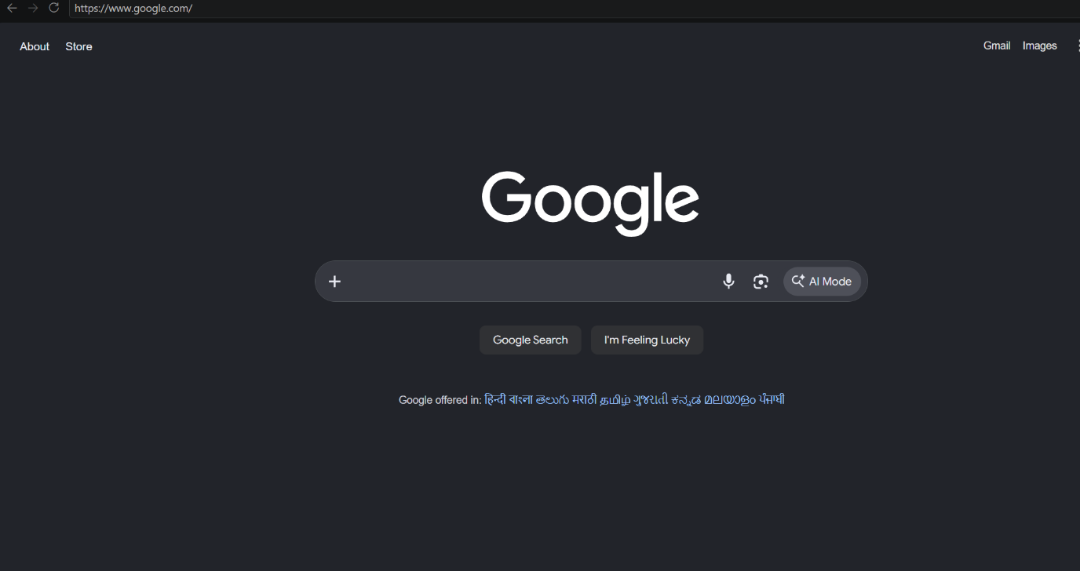

EXPERIMENT NO. 9
AIM: - Design an image map with clickable regions.
CODE: -
<html>
<head>
<title>2610997052</title>
</head>
<body>
<h1>Map of India</h1>
<center><img src="WhatsApp Image 2026-09-29 at 5.23.37 PM.jpeg" alt="Indiamap" usemap= “Indiamap"></center>

<map name="Indiamap">
<area shape="rect" coords="146, 50, 200, 94" href="https://en.wikipedia.org/wiki/Jammu_and_Kashmir_(union_territory)" alt="Jammu and Kashmir" target="_blank" title="Jammu and Kashmir">

<area shape="rect" coords="178, 123, 197, 145" href="https://en.wikipedia.org/wiki/Himachal_Pradesh" alt="Himachal Pradesh" target="_blank" title="Himachal Pradesh">

<area shape="rect" coords="145, 141, 165, 171" href="https://en.wikipedia.org/wiki/Punjab,_India" alt="Punjab" target="_blank" title="Punjab">

<area shape="rect" coords="212, 155, 233, 185" href="https://en.wikipedia.org/wiki/Uttarakhand" alt="Uttarakhand" target="_blank" title="Uttarakhand">

<area shape="rect" coords="158, 188, 175, 208" href="https://en.wikipedia.org/wiki/Haryana" alt="Haryana" target="_blank" title="Haryana">

<area shape="rect" coords="220, 207, 290, 275" href="https://en.wikipedia.org/wiki/Uttar_Pradesh" alt="UttarPradesh" target="_blank" title="Uttar Pradesh">

<area shape="circle" coords="120, 248, 60" href="https://en.wikipedia.org/wiki/Rajasthan" alt="Rajasthan" target="_blank" title="Rajasthan">

<area shape="poly" coords="325, 235, 339, 269, 321, 287, 384, 284, 392, 258,325, 235" href="https://en.wikipedia.org/wiki/Bhar" alt="Bhar" target="_blank" title="Bhar">
</map>

</body>
</html>

OUTPUT: -
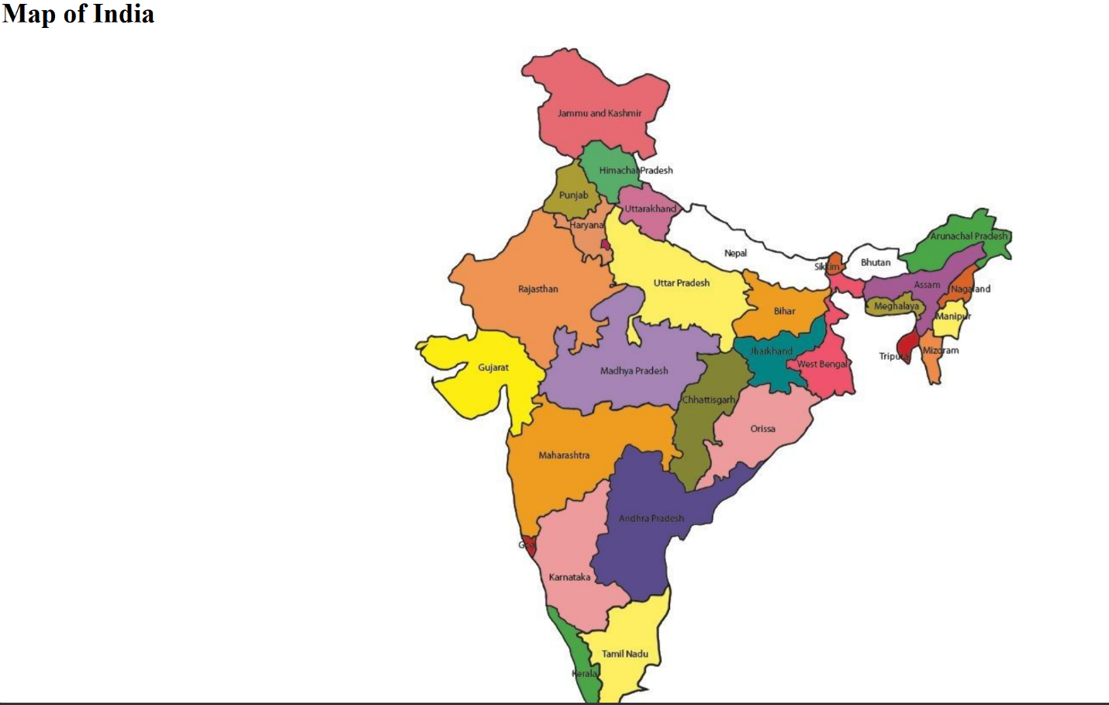

EXPERIMENT NO. 10
AIM: - Build a student marksheet table.
Code: - <html>
<head>
<title> 2610997052 </title>
</head>
<body >
Experiment No. 9<br>
<table border="2" cellspacing="0" cellpadding="5" align="center">
<tr>
<th>Sr. No</th>
<th>Student Roll No.</th>
<th>Student Name</th>
<th>Student Marks</th>
</tr>
<tr>
<td>1</td>
<td>987</td>
<td>A</td>
<td>90</td>
</tr>
<tr>
<td>2</td>
<td>988</td>
<td>B</td>
<td>85</td>
</tr>
</body>
</html>
OUTPUT: -
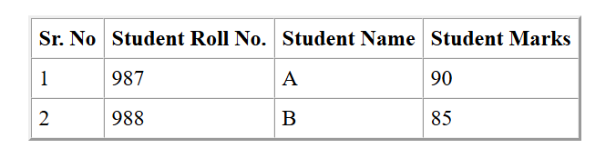

EXPERIMENT NO.11
AIM: - Create A Nested Timetable.
CODE: -
<html>
<head>
<title>261097052</title>
</head>
<body>
<center>
<h1>BCA1A</h1>
<table border="1" width="100%" cellspacing="0" cellpadding="10">

<tr>
<th></th>
<th>1<br>9:00 - 9:55</th>
<th>2<br>9:55 - 10:50</th>
<th>3<br>10:50 - 11:45</th>
<th>4<br>11:45 - 12:40</th>
<th>5<br>12:40 - 1:35</th>
<th>6<br>1:35 - 2:30</th>
<th>7<br>2:30 - 3:25</th>
<th>8<br>3:25 - 4:20</th>
</tr>
<tr>
<th rowspan="2">Mo</th>
<td rowspan="2" bgcolor="orange">
Stat.Maths<br><br>
</td>
<td rowspan="2"></td>
<td rowspan="1"></td>

<td colspan="2" rowspan="1" bgcolor="lightgreen">
<b>BasicCS-Lab</b><br>
DM-210 &nbsp;
</td>

<td rowspan="2"></td>
<td colspan="2" rowspan="1" bgcolor="lightgreen">
<b>PC-LAB</b><br>
DM-213 &nbsp;
</td>
</tr>

<tr>
<td colspan="2" bgcolor="yellow">
<b>UIDW-LAB</b><br>
TG-518 &nbsp;
</td>

<td colspan="2"></td>
</tr>

<tr>
<th rowspan="2">Tu</th>

<td colspan="2" rowspan="1" bgcolor="yellow">
<b>UIDW-LAB</b><br>
TG-518 &nbsp;
</td>

<td rowspan="2"></td>

<td rowspan="2" bgcolor="lightgreen">
<h1> <center>PC<br><br></h1></center>
</td>

<td rowspan="2"></td>

<td rowspan="2" bgcolor="orange">
Stat.Maths<br><br>PY
</td>

<td colspan="2" bgcolor="yellow">
<b>UIDW-LAB</b><br>
TG-518 &nbsp; AM / DR
</td>
</tr>

<tr>
<td colspan="2"></td>

<td colspan="2" bgcolor="lightgreen">
<b>PC-LAB</b><br>
DM-212 &nbsp;
</td>
</tr>

<tr>
<th rowspan="2">We</th>

<td rowspan="2"></td>

<td rowspan="2" bgcolor="orange">
Stat.Maths<br><br>
</td>

<td rowspan="2"></td>

<td colspan="2" bgcolor="yellow">
<b>UIDW-LAB</b><br>
TG-518 &nbsp;
</td>

<td rowspan="2"></td>

<td rowspan="2" colspan="2" bgcolor="lightcyan">
BasicCS<br><br>
</td>
</tr>

<tr>
<td colspan="2" bgcolor="lightgreen">
<b>BasicCS-Lab</b><br>
DM-212 &nbsp;
</td>
</tr>

<tr>
<th rowspan="2">Th</th>

<td colspan="2" bgcolor="yellow">
<b>UIDW-LAB</b><br>
TG-518 &nbsp;
</td>

<td rowspan="2" bgcolor="lightgreen">
PC<br><br>HS
</td>
<td rowspan="2"></td>
<td rowspan="2" bgcolor="lightcyan">
BasicCS<br><br>
</td>
<td rowspan="2"></td>
<td colspan="2" bgcolor="yellow">
<b>UIDW-LAB</b><br>
TG-518 &nbsp;
</td>
</tr>
<tr>
<td colspan="2"></td>
<td colspan="2" bgcolor="lightgreen">
<b>PC-LAB</b><br>
DM-211 &nbsp;
</td>
</tr>
<tr>
<th rowspan="2">Fr</th>
<td colspan="2" bgcolor="lightgreen">
<b>UIDW-LAB</b><br>
TG-518 &nbsp;
</td>
<td rowspan="2"></td>
<td rowspan="2" bgcolor="lightcyan">
BasicCS<br><br>
</td>
<td rowspan="2"></td>
<td colspan="2" bgcolor="lightgreen">
<b>PC-LAB</b><br>
DM-213 &nbsp;
</td>
<td rowspan="2"></td>
</tr>
<tr>
<td colspan="2"></td>
<td colspan="2" bgcolor="yellow">
<b>UIDW-LAB</b><br>
TG-518 &nbsp;
</td>
</tr>

<tr>
<th>Sat</th>
<td colspan="8"></td>
</tr>
</table>
</center>
</body>
</html>

OUTPUT: -

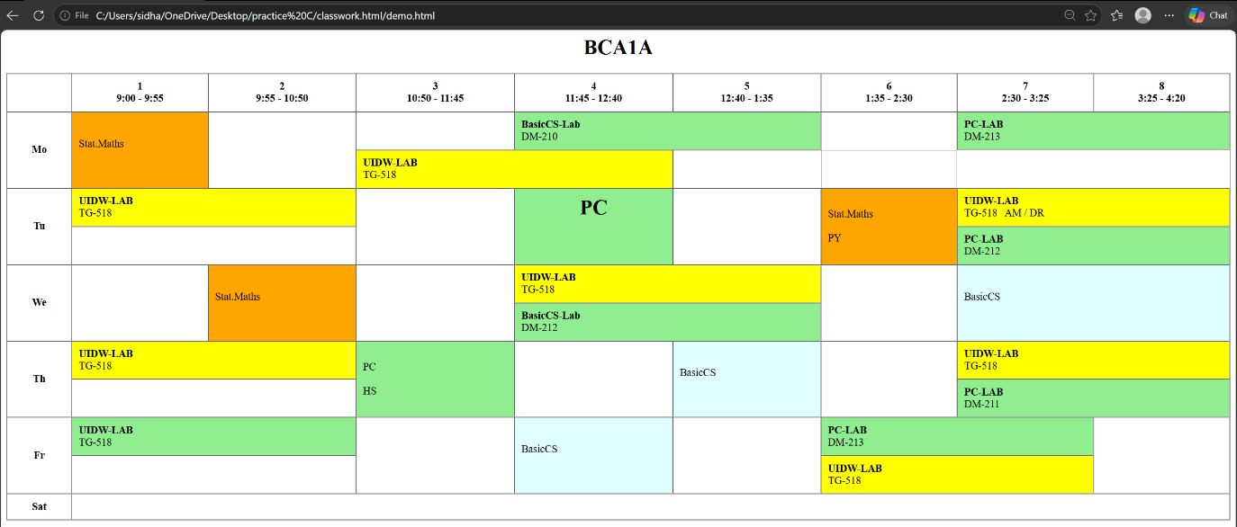

EXPERIMENT NO .12
AIM: - Design a table using rowspan or colspan.
CODE: -
<html>
<head>
<title>2610997052</title>
</head>
<body>

<h1>EXPERIMENT NO.12</h1>

<table border="1" cellpadding="10" cellspacing="0">
<tr>
<th colspan="4">ABC College</th>
</tr>
<tr>
<th>Roll No.</th>
<th>Name</th>
<th>Subject</th>
<th>Marks</th>
</tr>
<tr>
<td rowspan="2">101</td>
<td rowspan="2">Rahul</td>
<td>English</td>
<td>85</td>
</tr>
<tr>
<td>Computer</td>
<td>92</td>
</tr>
<tr>
<td>102</td>
<td>Priya</td>
<td>English</td>
<td>90</td>
</tr>
<tr>
<td colspan="3">Total Students</td>
<td>2</td>
</tr>
</table>

</body>
</html>

OUTPUT: -

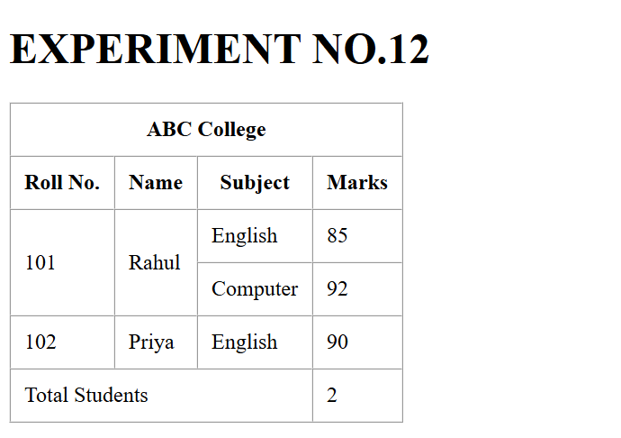

EXPERIMENT NO.13
AIM: - Build a registration form using GET method.
CODE: -
<html>
<head>
<title>2610997052</title>
</head>
<body bgcolor="pink">

<fieldset>
<legend align="center">STUDENT REGISTRATION FORM</legend>

<form>
<table bgcolor="pink" align="center" cellpadding="5">

<tr>
<td>FIRST NAME</td>
<td>
<input type="text" maxlength="30">
(max 30 characters a-z and A-Z)
</td>
</tr>

<tr>
<td>EMAIL ID</td>
<td><input type="email"></td>
</tr>

<tr>
<td>MOBILE NUMBER</td>
<td><input type="text" maxlength="10"></td>
</tr>

<tr>
<td>GENDER</td>
<td>
Male <input type="radio" name="gender">
Female <input type="radio" name="gender">
</td>
</tr>

<tr>
<td>ADDRESS</td>
<td><textarea rows="4" cols="25"></textarea></td>
</tr>

<tr>
<td>CITY</td>
<td>
<input type="text" maxlength="30">
(max 30 characters a-z and A-Z)
</td>
</tr>

<tr>
<td>PIN CODE</td>
<td>
<input type="text" maxlength="6">
(6 digit number)
</td>
</tr>

<tr>
<td>STATE</td>
<td>
<input type="text" maxlength="30">
(max 30 characters a-z and A-Z)
</td>
</tr>

<tr>
<td>COUNTRY</td>
<td><input type="text" value="India"></td>
</tr>

<tr>
<td>HOBBIES</td>
<td>
Drawing <input type="checkbox">
Singing <input type="checkbox">
Dancing <input type="checkbox">
Sketching <input type="checkbox">
Others <input type="checkbox">
<input type="text">
</td>
</tr>

<tr>
<td>QUALIFICATION</td>
<td>
<table cellpadding="3">
<tr align="center">
<th>SL.No</th>
<th>Examination</th>
<th>Boards</th>
<th>Percentage</th>
<th>Year of Passing</th>
</tr>

<tr>
<td>1</td>
<td>Class X</td>
<td><input type="text"></td>
<td><input type="text"></td>
<td><input type="text"></td>
</tr>

<tr>
<td>2</td>
<td>Class XII</td>
<td><input type="text"></td>
<td><input type="text"></td>
<td><input type="text"></td>
</tr>

<tr>
<td>3</td>
<td>Graduation</td>
<td><input type="text"></td>
<td><input type="text"></td>
<td><input type="text"></td>
</tr>

<tr>
<td>4</td>
<td>Masters</td>
<td><input type="text"></td>
<td><input type="text"></td>
<td><input type="text"></td>
</tr>
</table>
</td>
</tr>

<tr>
<td>COURSES APPLIED FOR</td>
<td>
BCA <input type="radio" name="course">
B. Com <input type="radio" name="course">
B.Sc <input type="radio" name="course">
B.A <input type="radio" name="course">
</td>
</tr>

<tr>
<td aligns="center" colspan="2">
<input type="submit" value="Submit">
<input type="reset" value="Reset">
</td>
</tr>

</table>
</form>
</fieldset>

</body>
</html>

OUTPUT: -

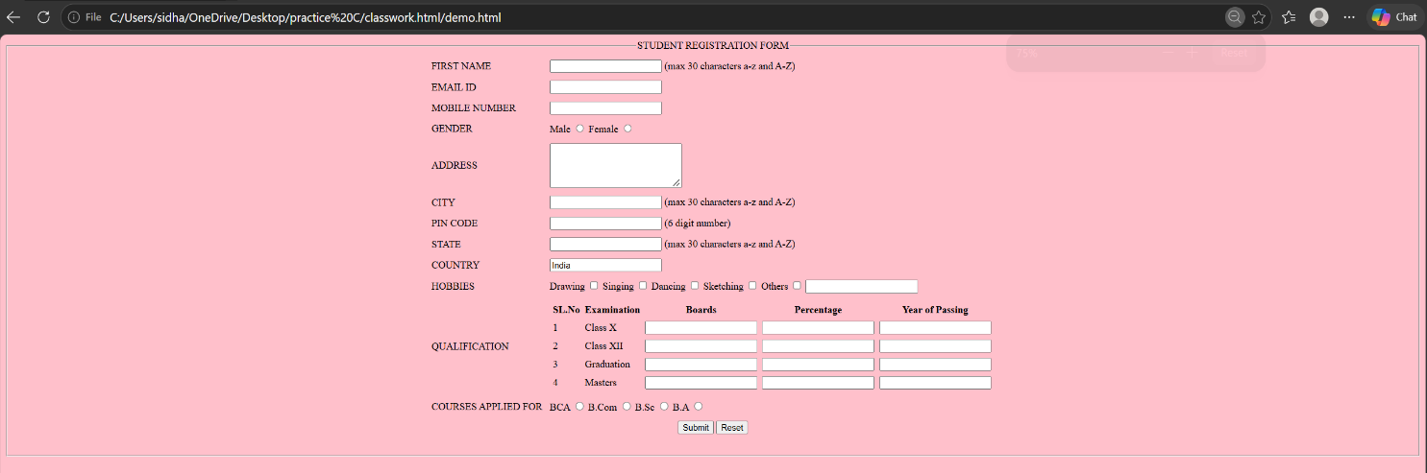

EXPERIMENT NO.14
AIM: -Build A Feedback Form Using Post Method.
CODE: -
<html>
<head>
<title>2610997052</title>
</head>
<body>
<fieldset>
<legend align="center">HP AGGENCY FEEDBACK FORM</legend>
<table>
<tr>
<td>NAME :</td>
<td><input type="text" maxlength="15" placeholder="your name"></td>
</tr>
<tr>
<td>EMAIL :</td>
<td><input type="email" maxlength="20" placeholder="enter your email id"></td>
</tr>
<tr>
<td>ADDRESS</td>
<td><textarea rows="3" cols="50"></textarea></td>
</tr>
<tr>
<td>POSTE CODE</td>
<td><input type="text"></td>
</tr>

<tr>
<table align="CENTER" border="1" cellpadding="10" bgcolor="yellowgreenblueredorange">
<br><br>
<tr>
<td>Product</td>
<td>Product Image</td>
<td>Quantity</td>
<td>Unit price</td>
<td>Subtotal</td>
</tr>
<tr>
<td>HP VICTUS</td>
<td> <img src="C:\Users\sidha\OneDrive\Desktop\practice C\classwork.html\images.jpg" align="center" height="100"></td>
<td><progress id="file-progress" max="100" value="70">70%</progress></td>
<td>120,000</td>
<td><input type="text"></td>
</tr>
<tr>
<td>HP OMEN SERIES</td>
<td> <img src="C:\Users\sidha\OneDrive\Desktop\practice C\classwork.html\images (1).jpg" align="center" height="100"></td>
<td><progress id="file-progress" max="100" value="65">65%</progress></td>
<td>250,000</td>
<td> <input type="text"></td>
</tr>
<tr>
<td>HP HYPERSTRIX OMEN</td>
<td> <img src="C:\Users\sidha\OneDrive\Desktop\practice C\classwork.html\images (2).jpg" align="center" height="100"></td>
<td><progress id="file-progress" max="100" value="50">50%</progress></td>
<td>200,000</td>
<td><input type="text"></td>
</tr>
<tr>
<td>HP 95 lx</td>
<td> <img src="C:\Users\sidha\OneDrive\Desktop\practice C\classwork.html\images (3).jpg" align="center" height="100"></td>
<td><progress id="file-progress" max="100" value="90">90%</progress></td>
<td>350,000</td>
<td><input type="text"></td>
</tr>
</table>
</tr>
</table>
<br>
<table width="100%">

<tr>

<br><br>
<td valign="top">

<form method="post">

<h2><b>CREDIT CARD DETAILS</b></h2>

<label>Card Holder Name:</label>
<input type="text" name="cardholder">
<br><br>

<label>Card Type:</label>

<select name="cardtype">
<option value="visa">Visa</option>
<option value="mastercard">MasterCard</option>
<option value="rupay">RuPay</option>
<option value="American Express">American Express</option>
</select>

<br><br>

<label>Card Number:</label>
<input type="text" name="cardnumber">
<br><br>

<label>Expiry Date:</label>
<input type="month" name="expiry">
<br><br>

<label>CVV:</label>
<input type="password" name="cvv" maxlength="3">
<br><br>

<label>Delivery address</label>
<input type="text" name="address" maxlength="100">

<br><br>

<input type="submit" value="Pay Now">
<br><br>
</form>
</td>

<td valign="top">

<form method="post">

<h2>FEEDBACK</h2>

<label>Rate Our Service:</label>

<br><br>

<input type="radio" name="rating" value="1"> ★
<input type="radio" name="rating" value="2"> ★★
<input type="radio" name="rating" value="3"> ★★★
<input type="radio" name="rating" value="4"> ★★★★
<input type="radio" name="rating" value="5"> ★★★★★

<br><br>

<label>Your Feedback:</label>

<br>

<textarea name="feedback" rows="5" cols="50"
placeholder="Write your feedback here"></textarea>

<br><br>

<input type="submit" value="Submit Feedback">

</form>

</fieldset>

</body>
</html>

OUTPUT: -
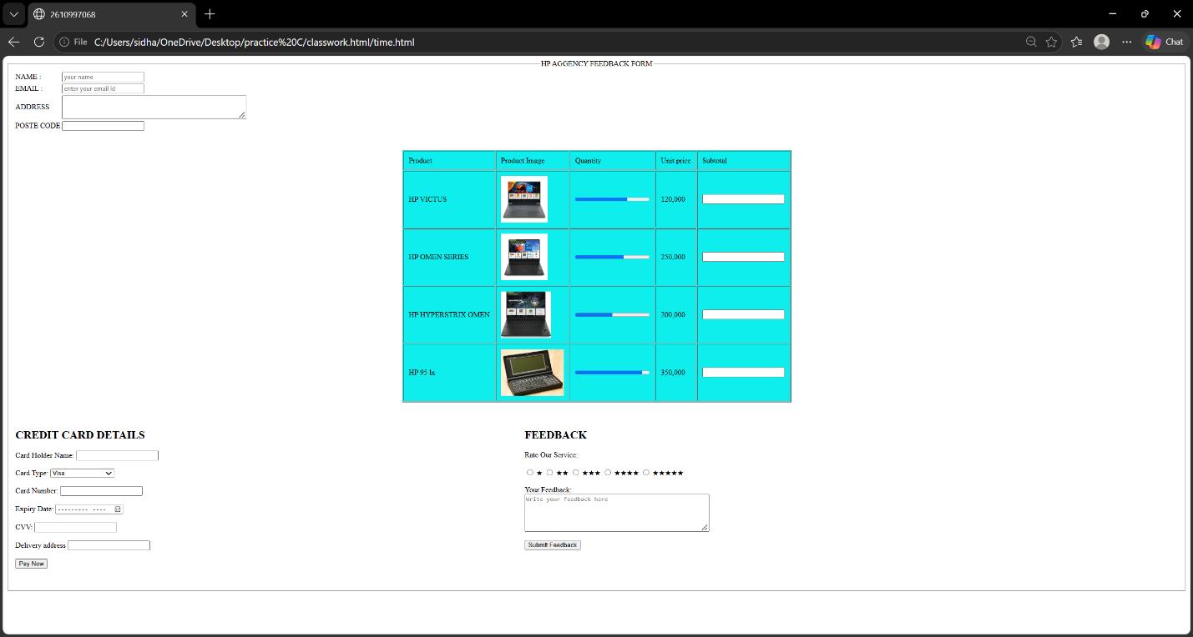

EXPERIMENT NO.15
AIM: - Compare Post and Get Methods.
GET Method | POST Method
1. GET is used to retrieve data from the server. | 1. POST is used to send data to the server.
2. Data is sent through the URL. | 2. Data is sent in the request body.
3. Data is visible in the URL. | 3. Data is not visible in the URL.
4. GET has a limited URL length. | 4. POST can send large amounts of data.
5. GET requests can be bookmarked. | 5. POST requests cannot normally be bookmarked with submitted data.
6. GET is used to search for or retrieve information. | 6. POST is used to submit forms or send information.
7. GET is generally used to read data. | 7. POST can be used to add or change data.
Example:
GET: Searching for information on Google.
POST: Submitting a registration form.
Code: - GET METHOD
<form method="get">
<input type="text" name="name">
<input type="submit" value="Submit">
</form>
POST METHOD: -
<form method="post">
<input type="text" name="name">
<input type="submit" value="Submit">
</form>

EXPERIMENT NO. 16
AIM: - Create A Frameset with Navigation and Content Frames.
Code: -
<head>
<title>2610997052</title>
</head>

<frameset rows="50%, 50%" cols="50%, 50%">
<frame src="https://i.pinimg.com/736x/36/88/29/3688299dca3d323248a6ab8e60073c0e.jpg " name="nav"></frame>
<frame src="https://i.pinimg.com/736x/6e/3c/40/6e3c406e42ad7314e0d1893a327a5998.jpg " name="content"></frame>
<frame src="https://i.pinimg.com/736x/04/09/50/040950140dee979ab98b7b390ff8cb14.jpg "></frame>
<frame src="https://i.pinimg.com/736x/41/f4/a9/41f4a92b184d73fe11ae606824815296.jpg "></frame>
</frameset>

</html>

</body>
</html>

Output: -



EXPERIMENT NO.17
AIM: -Embed an external website using iframe.
Code: -
<html>
<head>
<title>2610997052</title>
</head>
<body>

<h2>EXPERIMENT NO.17</h2>

<iframe src="https://www.wikipedia.org/"
width="800"
height="400"
title="Wikipedia Website">
</iframe>

</body>
</html>

OUTPUT: -
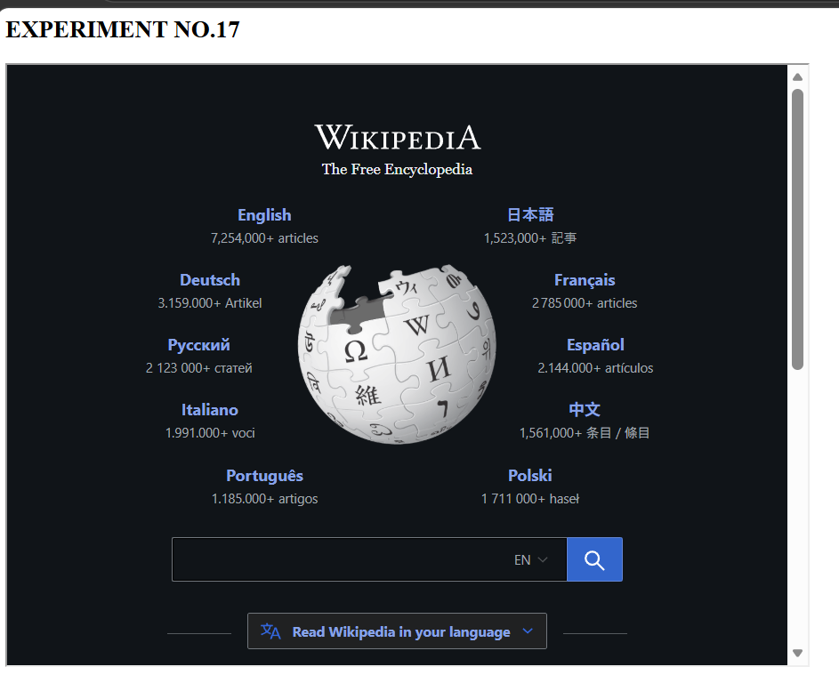
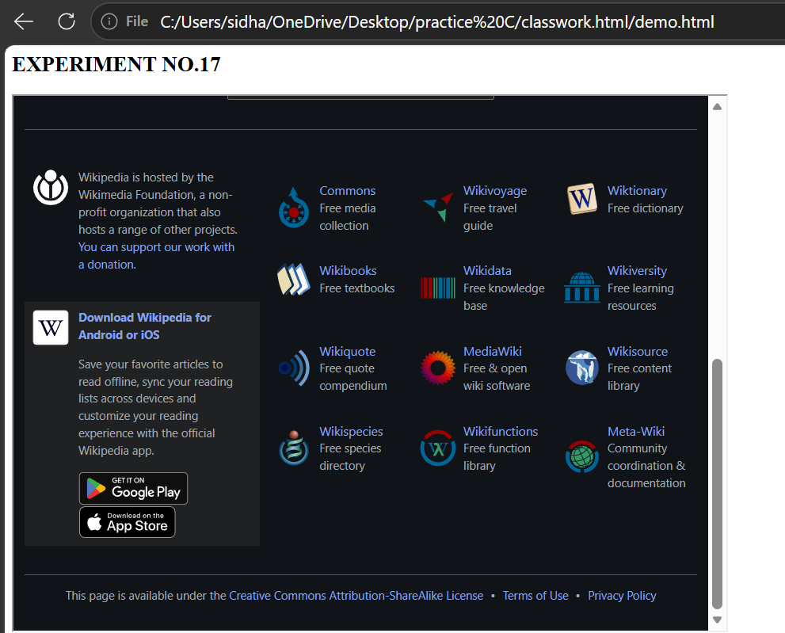

EXPERIMENT NO.18
AIM: - Display HTML special characters.
CODE: - <html>
<head>
<title>2610997052</title>
</head>
&trade; <br>
&copy; <br>
&reg; <br>
SUPER&nbsp; &nbsp;SAIYAN<br>
Hello&ensp; &ensp;Hii<br>
&lt; <br>
&gt; <br>
&pound; <br>
&euro; <br>
&yen; <br>
&divide; <br>
&larr; <br>
&rarr; <br>
&hearts; <br>
&quot; <br>
&times; <br>
&plus; <br>
&minus; <br>
</html>
OUTPUT: -


